Table 1 Major Dodd-Frank Rule-Making Areas

Table 2 Summary of Central Clearing Requirements in Major Financial Centers

Table 3 Sample Data for USD and CAD Yield Curves

Table 4 Number of Trades and Notional Value of USD and CAD denominated interest rate swaps market

Table 5 Selected Characteristics of Control Variables

Table 6 Difference-in-Differences result (pricing)

Table 7 Per Phase Difference-in-Differences Result (pricing)

Table 8 Placebo Difference-in-Differences Result (pricing)

Table 9: Difference-in-Differences (Liquidity)

Volatility Regression
===========================================================
Dependent variable: Realized Volatility
---------------------------------------
-----------------------------------------------------------
Group 0.4843***
(0.0832)
Period -0.0162
(0.1004)
Group * Period -0.0042
(0.1162)
Constant 0.1387*
(0.0718)
-----------------------------------------------------------
Observations 914
R2 0.0705
Adjusted R2 0.0675
Residual Std. Error 0.7628 (df = 910)
F Statistic 23.0192*** (df = 3; 910)
===========================================================
Note: *p<0.1; **p<0.05; ***p<0.01

Table 10 Difference-in-Differences (Realized Volatility)

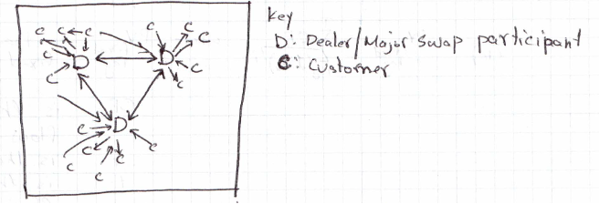
Figure 1

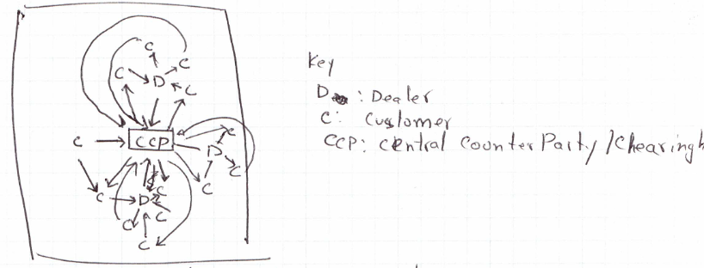
Figure 2

Figure 3

Figure 4

